Traffic Accident Mitigation

# Introduction

# Scope of the System

In relation to the scope of the project, along these chapter it is going to be describe the different applications and the requirements predefined for the development and implementation of the system.

On the one hand, the study of the most innovative, powerful and actual projects developed and also, the future projects and technologies that are going to be develop for the future will be covered on this document. With this, it is intended to know the current framework in which the system exists, as well as the needs and interests of the different organizations and the possibilities offered by the current technology for the development of the project.

On the other hand, this document is focused in the analysis of the different requirements in the modelling of the system of systems. To highlight the different systems involved, it is needed to attend to some entities, like the emergency operator’s system, whose are in charge of the emergency calls from the different injures or people that need some kind of assistance. They are the maximum responsible of understanding the caller´s situation as well as understanding the needs. For instance, in the community of Madrid, there are around 240 professionals and another 200 from other urgency services, behind the service 1-1-2 to attend all the emergency calls from the city. This service is designed according to a criterion that allows all emergency agencies to be operatively integrated, through the precise agreements to define the procedures that determine when each service must be activated.

As for the organizations involved in the process of attention to victims, they must have accurate information to deal with the incident, which includes geolocation, provided with some minimum degree of precision, the needs to be covered and a description of the current situation, as well as the road or location where the accident happened, to know its accessibility. It should be mentioned that the efforts destined to each operation (unities of ambulances, fire-fighters and policeman), must be the necessary ones, in order to cover the high demand and optimize the attention time.

The project aims to de-involve the human factor or, in other words, the accident victims from the process. In this way, the injured or possible witnesses will not need to make a call or notice to the emergency services. This is a breakthrough, since the participation of one or more individuals who may have symptoms of anxiety, shock or nervousness is eliminated from the process, and in some cases, they do not know how to identify the accident or the exact location of the events. On the other hand, it is intended to delegate these functions to the vehicle itself, which will be the one to notify emergency services in the first instance, as well to a UAV system that will allow a determination and analysis of the needs and situation of the accident with high accuracy and speed. For the implementation of the UAV swarm, a node design is carried out that transmits the information of the different sensors.

The development of a platform for the management of the emergency service will be essential. In this way, the different situations can also be controlled from the operations center and even derive the history of data to different relational and non-relational databases, in order to improve the behaviour of the system according to the response granted to previous accidents.

It is very important highlight the importance of the car industry for the development. It is because, one of the key elements in the project is a black box that will be integrate in the cars, in order to be able to send alerts when some kind of problem is detected or an accident occurs. The system alert message can be controlled according to the type of incident detected, so that the maximum information is available as quickly as possible, without putting those affected at risk. Therefore, a study of the different stakeholders will be carried out in chapter 4.

There will be a first design of a robust and scalable project in order to do all the necessary improvements before the implementation in the maximum number of cars as possible. This step is totally necessary to develop a first scenario where to study the response of the system and adjust it to an optimal operation.

The next step is the scaling of the system and the agreement with the different entities that are part of the system of systems to be able to implement the platform as soon as possible and increase the number of vehicles that have the system gradually.

This development of the project assumed that there will be collaboration between the different entities that will be part of the system. So, it is very important the communication and standardization of the messages and the way to transmit the alert to the platform to be use by the emergency services in an easy and friendly way. This assumption of collaboration is based on the fact that nowadays there are some projects that have been implemented under the work developed by these entities together, like is described in the next chapter.

The justification for the development of the system is to help in the coordination between entities and to mitigate the risks in the traffic accidents. This will suppose a big improve in the design of cars that will be connected to the emergency services and will offer a more closed relation between these organizations in order to create a much more safety way to travel.

The project will be implemented in Madrid, before being developed in other regions or countries, under the financing of the European Union, as it is a first instance of a research project, to increase the efficiency and standardization of the platform. In this way a high level of compatibility will be achieved between the various brands and vehicle manufacturers, to include the black box in the design of the cars, and, for the development of security in the transmission of data packets, as well as easy understanding in the way of use the platform. For this, the different communication protocols between organizations and the various current forms of action will be studied. In addition, the development will be based on the study of the current solutions in the market, in order to distinguish the success factors and the possible problems raised in the implementation (autonomy of UAVs, speed and consistency in the transmission of data etc.).

# Current solutions

In this chapter, the most innovative solutions provided by the organizations and entities involved in the development of the technology will be analyzed. This study will be taken as a starting point for the modelling of the system of systems, the taking of requirements and the design of the architecture.

It should be noted that currently we are investigating the implementation of systems that use the IoV (Internet of Vehicles), to improve safety and immediate attention to possible accident victims, caused by all kinds of environmental, engineering problems or simply of the human factor.

# DGT

On the one side, the “General Directorate of Traffic” (Spain), has just deployed a system of drones intended for the surveillance of drivers and with the ability to fine in case of the sighting of an infraction. Such infractions such as throwing a cigarette butt or skipping a stop can be controlled directly by these drones. However, at the moment its application is not contemplated for any type of roadside assistance or the sighting and characterization of accidents.

As for the inclusion of new technologies by the DGT, they are mainly applied to systems of warning of involuntary lane change or automatic or autonomous braking. However, it is desired to move the development of mobile applications, intelligent systems or Big Data to the field of road safety and mobility. The ultimate goal is to change the way we use roads and vehicles; thus, expand the capacity and efficiency of roads or even choose the way of driving, such as going or even traveling without driving, that is, autonomously by the vehicle. We can find more details in [**BIBLIOGRAPHY**]

The most used methods are focused on the statistical study for the prevention of accidents, the determination of the main causes and even the reconstruction of the same to be able to analyse different components of relevance in the result of the accident itself. One of the examples is the analytical reconstruction of traffic accidents or their reconstruction using computer methods for 3-dimensional modelling.

In addition, there are several international databases with the characteristics of accidents, such as the BD “GIDAS”, “CCIS” or that of “Volkswagen” or INRETS-CEESAR. Therefore, the improvement or provision of new equipment or systems for accident assistance or the update of the methods of warning and detection of them by this body is not assessed.

# Emergencies services

Regarding the implementation of new technologies in emergency services, we can find, as one of the main objectives, the implementation of the “eCall” system in Center 112 of the community of Madrid. This system is embarked on vehicles and in case of emergency will make a call to the emergency number 112; The call will be made automatically by activating sensors or manually. This objective has been met in September 2018.

For further development of the claims of the European eCall project, it consists in the implementation of a device, which, incorporated into the vehicles, notifies the authorities and emergency bodies, in a period of 15 to 30 seconds. However, in Spain, this time will be about 30 seconds considering that the call will have to go through the DGT first. Even so, it is intended to reach a figure close to 5% reduction in the number of victims and 6% in terms of the severity of the injured.

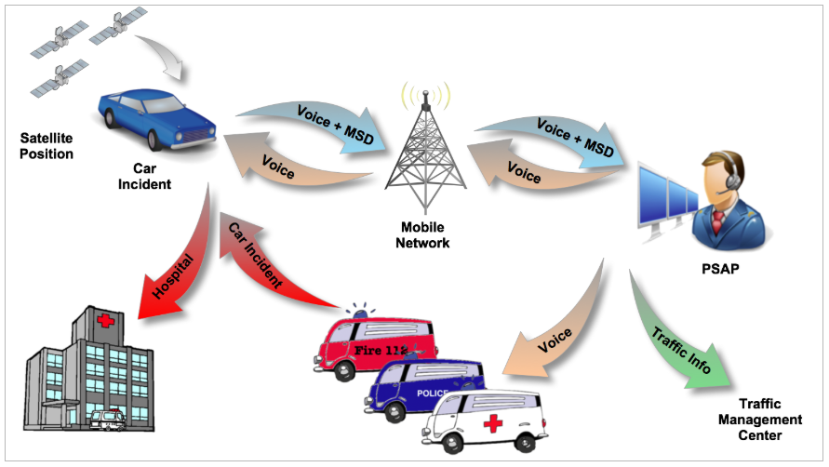

Illustration 1: Communication chain of eCall. Source: HeERO

In addition, in June 2017, the renewal of the telephone exchange and the management of emergency calls on IP technology took place.

As for applications for mobile devices, free applications such as “APP112 SOS DEIAK” or others such as assistance by “WhatsApp” or “Alpify-Safe365” are already available. These applications can be used to facilitate the work of rescue teams in situations of risk or loss of people, thanks to geolocation.

It is worth mentioning the current benefits of the emergency call service 112, since it allows activating all the agencies simultaneously improving the response time, in addition, it allows the immediate location of the caller and is designed with scalability criteria that allow incorporating new technologies such as the modelling object of this project.

# Other examples

We can find different publications that refer to the inclusion of new technologies for the assistance and detection, in the first instance, of traffic accidents. As is the case in the document on the IEEE 8th International Conference on Consumer Electronics in Berlin, Germany in 2018. In that paper it is proposed a Deep-learning based Internet of Vehicles system, which consist of an in-vehicle infotainment telematics platform with collisions detection sensor and a cloud based deep learning training server and a web-based service platform. The goal of this system is shown as an experimental result, where the accuracy of traffic accident collisions detection can be achieved up to 96%, as well as improve the average response time to send the emergency announcement of approximately 7 seconds. The following picture shows an example of the IoV system applied to the traffic accidents immediately collisions detection, analysis, and alarms:

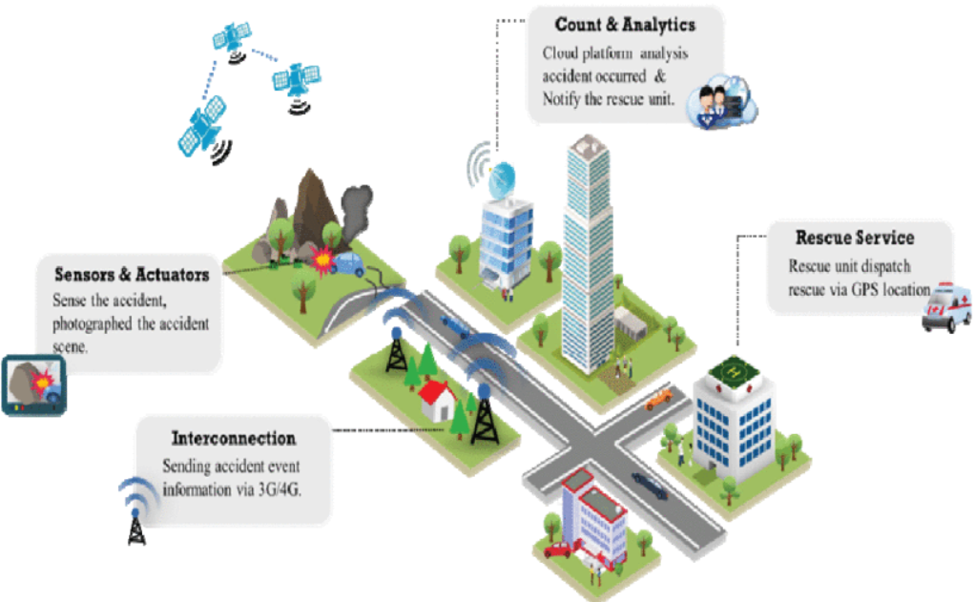

Illustration 2: Example of an IoV system applied to the traffic accidents.

The biggest problem to solve lies in the figures. The global status report on road safety 2015 of the World Health Organization (WHO) [**Bibliography**], pointed out that about 1.25 million people die each year due to traffic accidents in the world, indirectly caused from 20 to 50 million people to have nonlethal injuries. Also, about 90 % of road traffic accidents occurred in low and middle income countries where the low level of emergency rescue energy and medical standards are the causes of a bigger mortality rate of accidents.

# Conclusions

Regarding the conclusions obtained once the study of the current situation on the implementation of different technologies for the assistance and detection of accidents, or the improvement in communication between emergency entities (such as police, fire fighters or health care) has been carried out. In a first instance, certain solutions have been found with similar characteristics to those proposed in the system modelling of this document. However, none of them has a drone system to facilitate such communications and the characterization of the damage and needs that the accident presents. So, the project can be framed in the innovation or improvement of some of the services and projects proposed in recent years, but which, incorporates new features, as well as a much more efficient use of the resources we have available in terms of emergency care and services.

It is worth mentioning that the projects developed so far, are focused on meeting the needs of several entities and organizations at the same time, so a close collaboration between them is required. These examples help to understand the current needs of these organizations and even the most relevant aspects to be covered by the project.

The fact of finding several examples with similar characteristics demonstrates the interest of the different organisms involved, in the development of this type of technologies. In this way, it is possible to improve and update emergency services, which constitute one of the factors of greatest interest to the citizen.

Therefore, through the development of this new technology, its scalability and standardization are intended. Since, currently, there are different collaborating entities such as car brands or the emergency agencies themselves or even the police, as has been observed in the solutions proposed in the previous subsections.

# Stakeholders

# Resultado de imagen de stakeholders

# Customers

# Govermments

# Communitles

# Suppliers

# Investors

# Employees

# Current Systems in the market and in Spain goberment

# Analysis

# Functional requirements

# Non-functional requirements

# Use cases

# Desing

# Systems chosed and compose the SoS solution

# Architecture patterns chosed

# Architecture diagram

Bibliografía:

DGT:

**[DOC]**

### **[TTEMA - planificación de RRHH - DGT](http://www.dgt.es/Galerias/la-dgt/empleo-publico/oposiciones/doc/2013/TEMA_41_Parte_Comun_mov_segura26e.doc)**

<http://www.dgt.es/es/sistemas-seguridad-vehiculos/nuevas-tecnologias/index.shtml>

<https://www.elconfidencial.com/tecnologia/2019-08-28/drones-multas-dgt-radares-vacios_2193495/>

<http://www.dgt.es/Galerias/seguridad-vial/investigacion/plan-investigacion/20170302-PLAN-INVESTIGACION-E-INNOVACION.pdf>

emergency systems:

<https://www.comunidad.madrid/transparencia/compromiso/incorporacion-nuevas-tecnologias-emergencias>

<http://www.madrid.org/112/index.php/que-es-el-112/beneficios-del-112-para-el-ciudadano>

<https://www.tendencias21.net/Nuevo-sistema-para-coches-avisa-a-emergencias-si-se-produce-un-accidente_a30688.html>

<https://www.europapress.es/madrid/noticia-112-recibe-ahora-45-millones-llamadas-ano-frente-millon-primer-ano-1998-20181130150457.html>

IEEE:

<https://ieeexplore.ieee.org/document/8576197>

WHO:

 Global status report on road safety 2015, 2015, [online] Available: http://www.who.int/violence_injury_prevention/road_safety_status/2015/en.